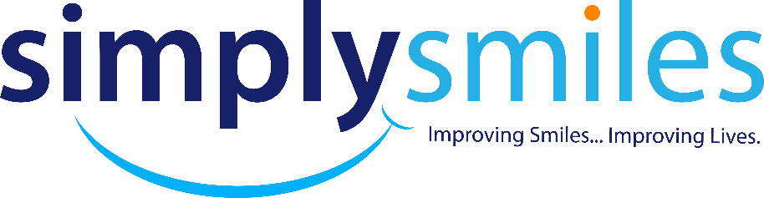
Please
Initial

________ CANCELLATION POLICY:
Simply Smiles Dentistry, understand that illness, emergencies, flat tires, and bad weather
do occur. We ask our patients to give us 48 hours’ notice whenever possible, if they cannot
keep an appointment. This allows us time to fill our schedule with other patients who may
be waiting. Failure to provide 48 hours’ will result in a cancellation fee of $50.00 per
scheduled hour.

________ PAYMENT POLICY:
Simply Smiles Dentistry expects payments at the time of service. We have payment options
that consist of Cash, Check, Debit or Credit and a third party Financing option thru Care
Credit and/or Wells Fargo Health Advantage that allows you to do small monthly payments
with 0 interest for 12-18 months or up to 60 months with interest attached.

________ INSURANCE POLICY:
We ESTIMATE your patient portion based on information we are given from your insurance
company. Any UNPAID amounts from you insurance will be the responsibility of the patient
upon receipt of statement.

________ CONFIRMATION OF APPOINTMENTS:
We do REQUIRE that our patients’ confirm their appointments. We utilize an email, text, and
phone call system to make the confirmation process easy.

________ LATE ARRIVAL
We encourage our patients to arrive 10 min prior to their scheduled appointment time. We
will have to reschedule you if you are more than 15 min late and will be charged $50.00
Late/cancellation fee.

Acknowledgement of policies________________________________Date_______________________

